**ASSIGNMENT NO.4**

Name: NEIL CARDOZ Roll no: 2307012079

Batch: AIML B1

Title: DECK

1. Main.java

// Main.java

//Name - Neil Cardoz

//PRN - 23070126079

//Batch - AIML B1

import java.util.Scanner;

public class Main {

public static void main(String[] args) {

Scanner scanner = new Scanner(System.in);

Deck deck = new Deck();

deck.createDeck(); // Initialize the deck with cards

int choice;

do {

System.out.println("\nMenu:");

System.out.println("1. Print Deck");

System.out.println("2. Print a Random Card");

System.out.println("3. Find a Card");

System.out.println("4. Shuffle Deck");

System.out.println("5. Deal 5 Random Cards");

System.out.println("6. Compare Two Cards");

System.out.println("7. Check if Two Cards Have the Same Suit");

System.out.println("8. Exit");

System.out.print("Enter your choice: ");

choice = scanner.nextInt();

switch (choice) {

case 1:

deck.printDeck();

break;

case 2:

deck.printCard();

break;

case 3:

System.out.print("Enter card rank: ");

String rank = scanner.next();

System.out.print("Enter card suit: ");

String suit = scanner.next();

deck.findCard(rank, suit);

break;

case 4:

deck.shuffleDeck();

System.out.println("Deck shuffled successfully.");

break;

case 5:

deck.dealCard();

break;

case 6:

System.out.println("Enter details for the first card:");

System.out.print("Rank: ");

String rank1 = scanner.next();

System.out.print("Suit: ");

String suit1 = scanner.next();

System.out.println("Enter details for the second card:");

System.out.print("Rank: ");

String rank2 = scanner.next();

System.out.print("Suit: ");

String suit2 = scanner.next();

boolean sameRank = deck.compareCard(new Card(rank1, suit1), new Card(rank2, suit2));

System.out.println("Do the cards have the same rank? " + sameRank);

break;

case 7:

System.out.println("Enter details for the first card:");

System.out.print("Rank: ");

String r1 = scanner.next();

System.out.print("Suit: ");

String s1 = scanner.next();

System.out.println("Enter details for the second card:");

System.out.print("Rank: ");

String r2 = scanner.next();

System.out.print("Suit: ");

String s2 = scanner.next();

boolean sameSuit = deck.sameCard(new Card(r1, s1), new Card(r2, s2));

System.out.println("Do the cards have the same suit? " + sameSuit);

break;

case 8:

System.out.println("Exiting program.");

System.out.println("Exiting program.");

break;

default:

System.out.println("Invalid choice. Try again.");

}

} while (choice != 8);

scanner.close();

}

}

2. Card.java

// Card.java

import java.util.*;

class Card{

String rank;

String suit;

public Card(String rank, String suit) {

this.rank = rank;

this.suit = suit;

}

public String getRank() {

return rank;

}

public String getSuit() {

return suit;

}

public String toString() {

return rank +" of "+ suit;

}

}

3. Student.java

//Deck.java

import java.util.*;

class Deck {

ArrayList<Card> deck;

public Deck(){

deck = new ArrayList<>();

}

public void createDeck(){

String[] ranks = {"A","2","3","4","5","6","7","8","9","10","J","Q","K"};

String[] suits = {"Hearts", "Spades", "Diamonds", "Clubs"};

for (String rank: ranks){

for(String suit: suits){

deck.add(new Card(rank,suit));

}

}

}

void printDeck() {

for(Card card : deck) {

System.out.println(card);

System.out.println("Deck shuffled.");

}

}

public void shuffleDeck(){

Collections.shuffle(deck);

}

// Print 1 randomcard from the deck

public void printCard(){

Collections.shuffle(deck);

System.out.println("The cards is "+deck.get(1));

}

// Method to check if two cards belong to the same suit

public boolean sameCard(Card c1, Card c2) {

return c1.getSuit().equals(c2.getSuit());

}

// Method to check if two cards have the same rank

public boolean compareCard(Card c1, Card c2) {

return c1.getRank().equals(c2.getRank());

}

// Method to find and print a specific card

public void findCard(String rank, String suit) {

for (Card card : deck) {

if (card.getRank().equals(rank) && card.getSuit().equals(suit)) {

System.out.println("Card found: " + card);

return;

}

}

System.out.println("Card not found.");

}

// Method to deal 5 random cards

public void dealCard() {

Collections.shuffle(deck);

System.out.println("Dealt 5 random cards:");

for (int i = 0; i < 5; i++) {

System.out.println(deck.get(i));

}

}

}

4. Output

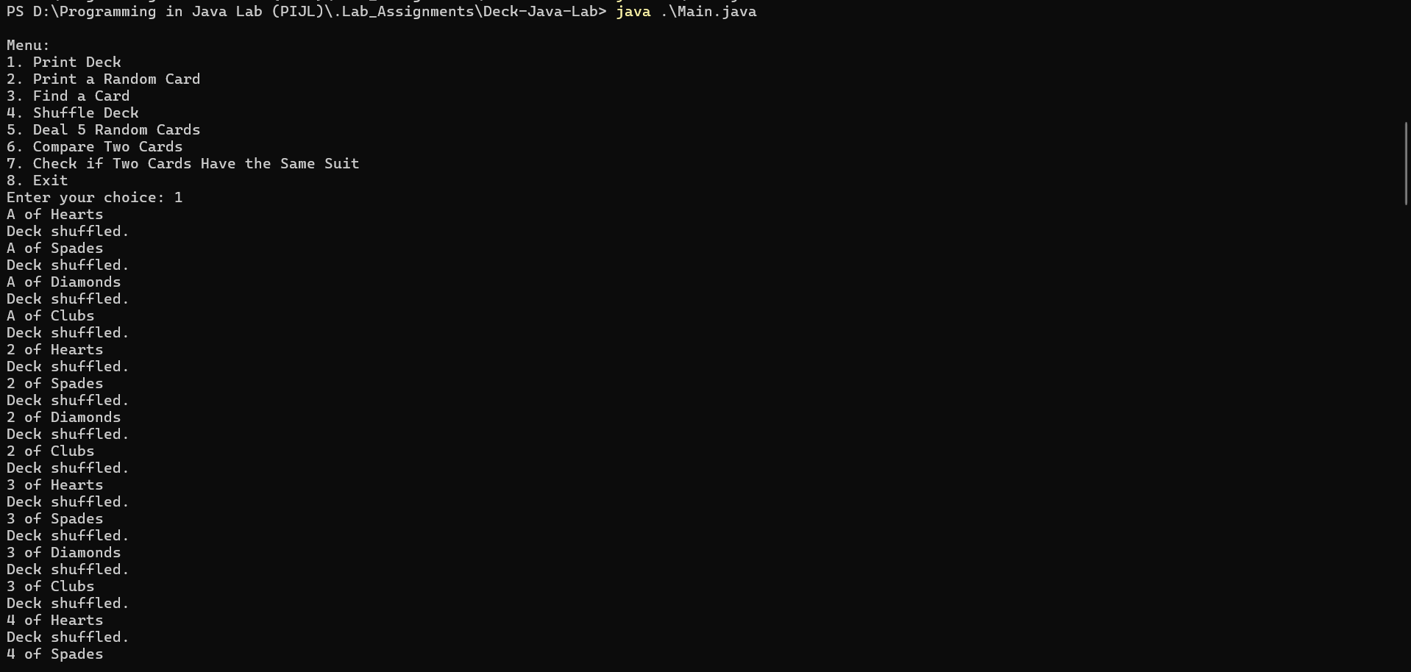

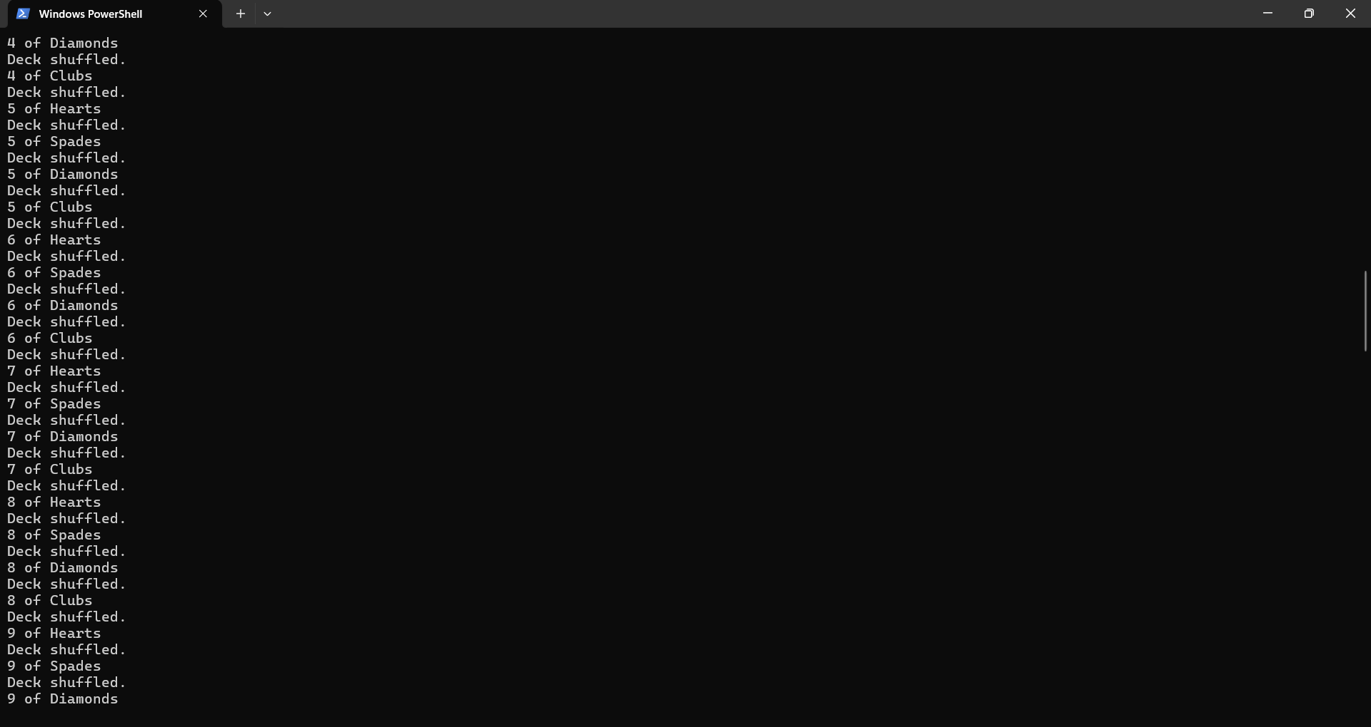

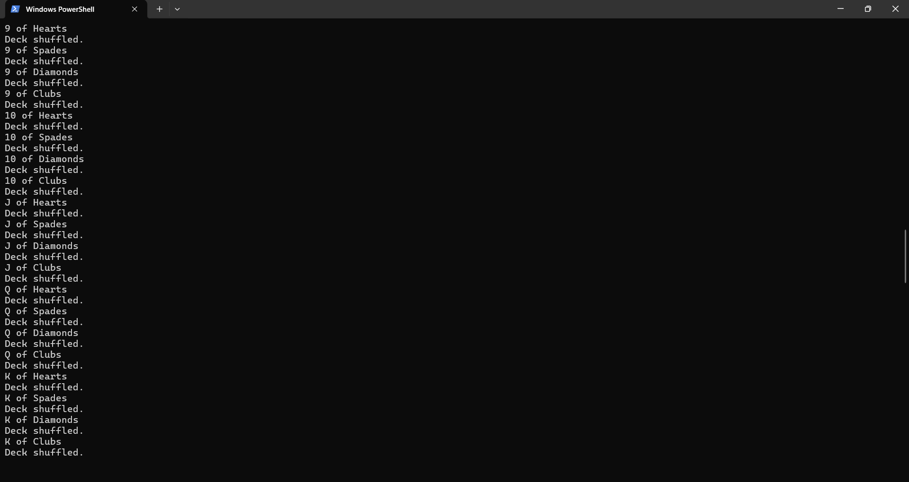

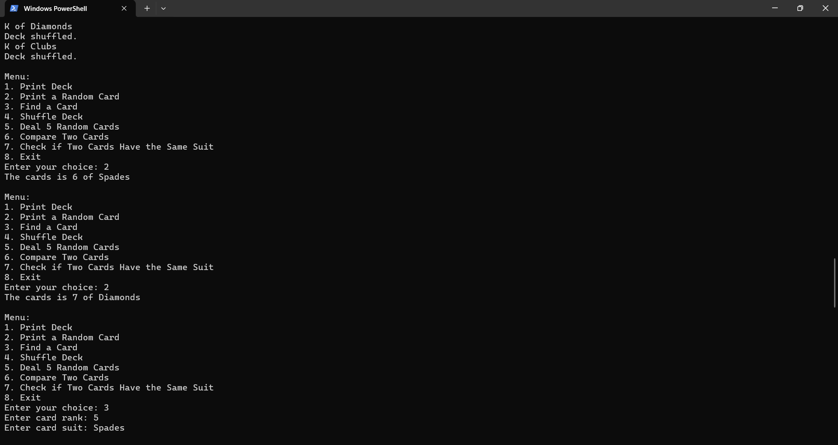

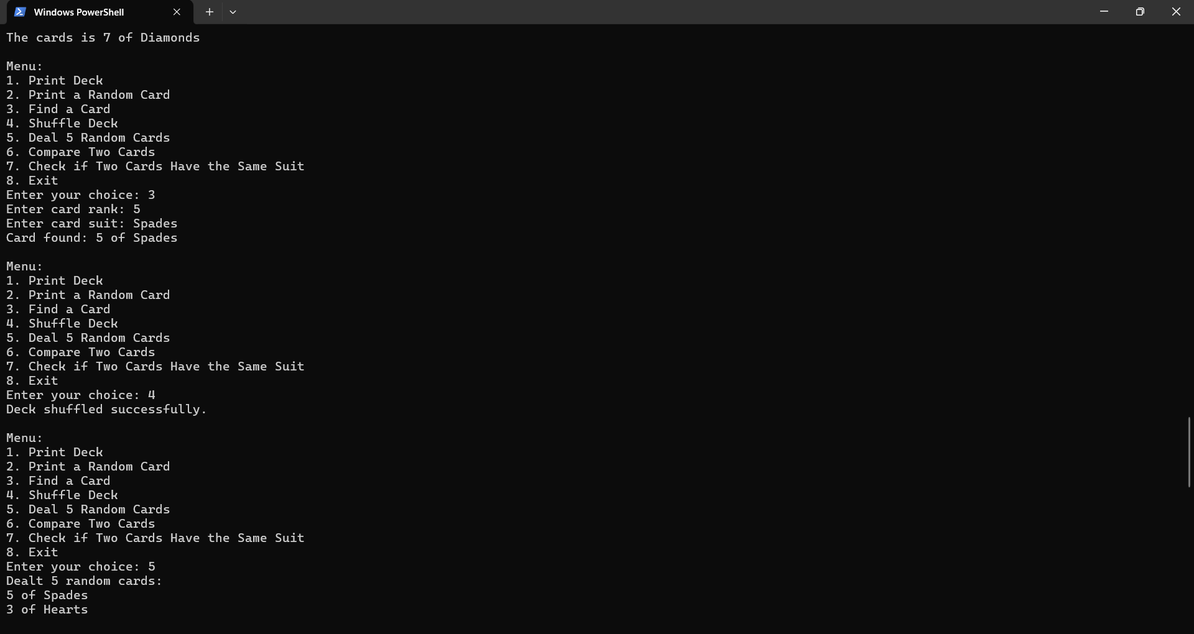

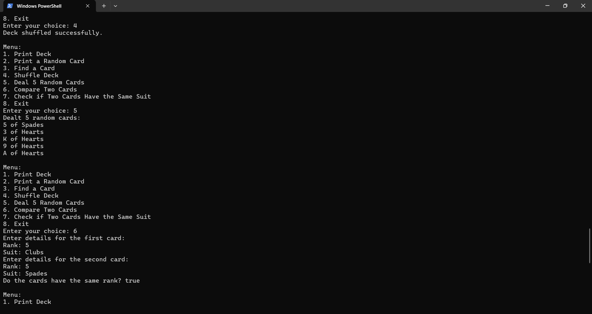

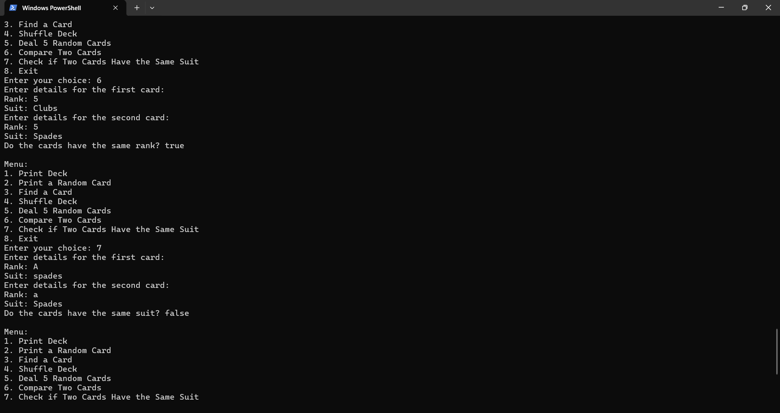

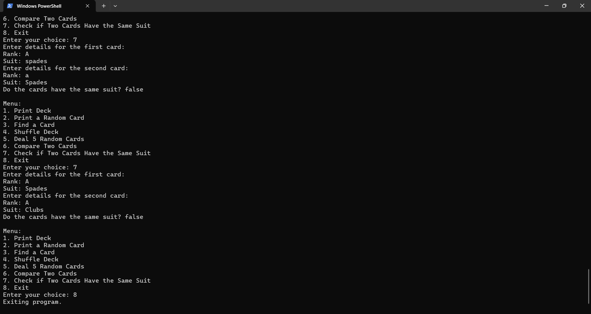

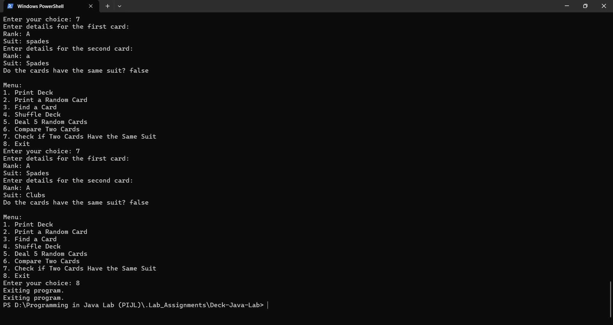

5. Repository

http://github.com/Neil-Cardoz/Deck-Java-Lab